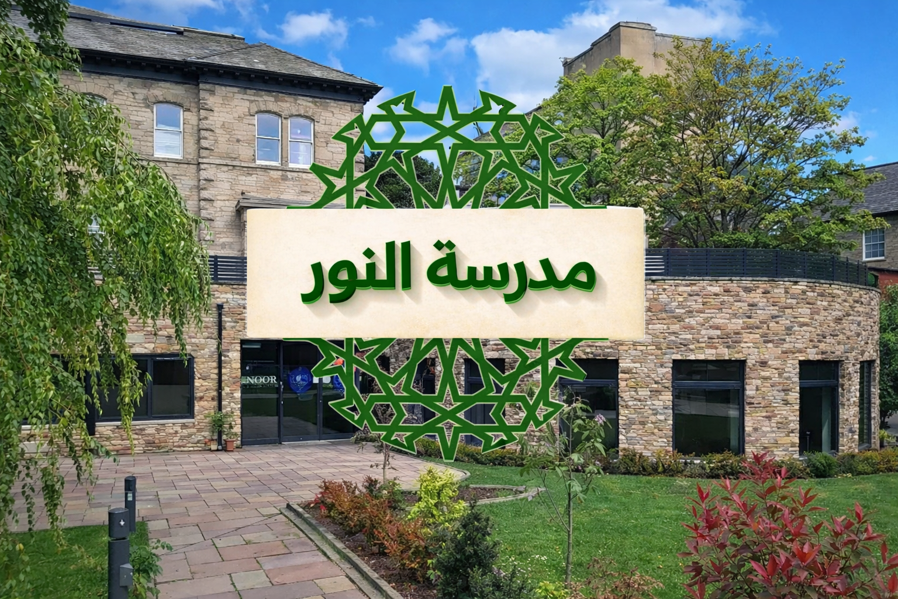

Safeguarding Forms
Templates for Recording and Reporting

Madrasah Noor Lancaster — Lancaster Islamic Community Hub

Safeguarding Concern / Disclosure Form

Complete as soon as possible and pass to the DSL immediately.

Child details
Child name | ______________________________
Date of birth / age | ______________________________
Class / group | ______________________________

Concern details
Date and time of concern | ______________________________
Reported by (name/role) | ______________________________
Type (disclosure / observation / other) | ______________________________

What was said / seen (include the child’s exact words where possible)
______________________________________________________________________________
______________________________________________________________________________
______________________________________________________________________________

Action taken so far
______________________________________________________________________________
______________________________________________________________________________

DSL decision and next steps
Received by (DSL) | ______________________________
Date/time received | ______________________________
Decision (monitor / early help / referral) | ______________________________
Referral made to (if applicable) | ______________________________
Reference / contact details | ______________________________
Signature (DSL): ____________________________ Date: ______________________

Allegation / Concern About an Adult (Staff or Volunteer)

Report immediately to the Head and/or DSL. Do not investigate yourself.

Adult details
Name | ______________________________
Role | ______________________________
Date/time concern raised | ______________________________
Reported by | ______________________________

Details of allegation / concern
______________________________________________________________________________
______________________________________________________________________________
______________________________________________________________________________

Immediate actions taken
______________________________________________________________________________

DSL/Head actions and advice sought
LADO contacted? (Y/N) | ____
LADO email | lado.admin@lancashire.gov.uk
Children’s Social Care / Police contacted? (Y/N) | ____
Notes / reference number | ______________________________
Signed (Head/DSL): __________________________ Date: ______________________

Staff / Volunteer Safeguarding Sign-Off

I confirm that I have read and understood:
- Madrasah Noor Staff Safeguarding Handbook
- How to report a concern to the DSL
- Staff conduct and professional boundaries
- Online safety and photography expectations
Name | ______________________________
Role | ______________________________
Signature | ______________________________
Date | ______________________________

Safeguarding Training Record (per person)

Use this page to record safeguarding training and refreshers for one person.
Date | Training / content | Provider / notes
__________ | ______________________________________________ | ______________________________________________
__________ | ______________________________________________ | ______________________________________________
__________ | ______________________________________________ | ______________________________________________
__________ | ______________________________________________ | ______________________________________________
__________ | ______________________________________________ | ______________________________________________

