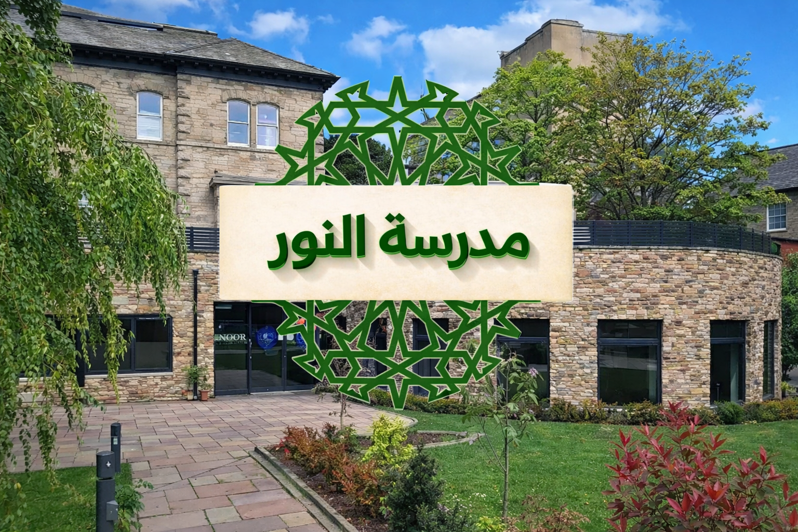

Safeguarding Handbook
For Staff and Volunteers

Madrasah Noor Lancaster — Lancaster Islamic Community Hub

Key contacts
Head | Mowlana Nawaz Munshi
Designated Safeguarding Lead (DSL) | Anas Patel
Deputy DSL | To be appointed
Children's Social Care (Lancashire) — day | 0300 123 6720
Children's Social Care — out of hours | 0300 123 6722
Police — emergency | 999
Police — non-emergency | 101
NSPCC helpline | 0808 800 5000
LADO email (allegations about adults) | lado.admin@lancashire.gov.uk
This handbook is the minimum day-to-day safeguarding guidance for all staff and volunteers at Madrasah Noor Lancaster. If in doubt, always seek advice from the DSL. If you believe a child is in immediate danger, call 999.

The 4 R’s
- Recognise: notice signs, changes in behaviour, or a disclosure.
- Respond: stay calm, listen, and take the child seriously.
- Record: write a factual record as soon as possible (date/time, exact words).
- Refer: pass the concern to the DSL immediately; do not investigate yourself.

If a child discloses to you
- Listen carefully. Allow them to speak freely.
- Reassure them they have done the right thing by telling you.
- Do not promise confidentiality; explain you may need to share to keep them safe.
- Do not ask leading questions. Only ask open questions if needed (who/what/when/where).
- Report to the DSL immediately and complete a concern form.

Recording a concern
Make a written record as soon as possible. Use the Safeguarding Concern Form and include: date/time; your name; the child's details; what you saw/heard; the child's exact words; any injuries observed; and what action you took. Records are stored securely and only shared on a need-to-know basis.

Referral and escalation
The DSL will decide next steps, which may include monitoring, contacting parents (where appropriate), seeking early help, or making a referral to Children's Social Care / Police. Staff should follow Lancashire Safeguarding Partnership procedures manual (Tri.x) when guidance is needed.

Concerns or allegations about an adult
Any concern about the behaviour of a member of staff or volunteer must be reported immediately. Report to the Head and/or DSL (if the concern is about the Head, report to the DSL and management committee). The DSL/Head will seek advice from the LADO when appropriate.

Staff conduct and boundaries
- Treat all children with respect and maintain professional boundaries.
- Avoid being alone with a child. If 1:1 is necessary, keep doors open/visible and inform another adult.
- Do not exchange personal contact details or communicate privately with children on social media.
- Physical contact should be appropriate, minimal, and in line with the child’s needs and consent.
- Do not take photographs/videos on personal devices unless authorised and consented.

Online safety and devices
Children should be protected from harmful content and unsafe contact online. Staff should: supervise device use where relevant, follow madrasah guidance for photos/videos, and report any online safety concern to the DSL.

Specific safeguarding themes
Staff should be aware of safeguarding indicators linked to:
- Child sexual exploitation (CSE)
- Female genital mutilation (FGM)
- Radicalisation / Prevent concerns
- Peer-on-peer abuse (including bullying)

Training and sign-off
All staff and volunteers must read this handbook, know who the DSL is, and complete safeguarding training as directed. You must sign the staff sign-off sheet to confirm you have read and understood the safeguarding expectations.
Review: This handbook is reviewed annually or sooner if guidance changes.

